Susquehanna Shad Lab

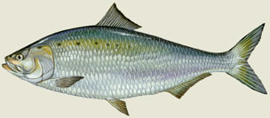
The American shad or white shad, Alosa sapidissima, is the best-known of the six species of shad and herring that swim in the Chesapeake Bay. This shad is a handsome fish, with a metallic blue-green back that lightens to silver along the sides and has a black spot at the shoulder, with several smaller spots trailing behind. The American shad can reach a length of 30 inches, and is the largest—and considered the most delicious to eat–of all the shads.
Define Anadromous -
The anadromous American shad is indigenous to the Atlantic coast from the St. Lawrence River to Florida, and spends most of its life at sea in large schools. It only enters the freshwater river in which it was born to spawn.
Shad undertake extensive ocean migrations, spending the summer and fall in the Gulf of Maine and overwintering in deeper offshore waters. As the shad migrates from salt water to fresh, its cloak of large, easily-shed scales dulls from blue-green to brown.
During an average life span of five years at sea, the American shad may migrate more than 12,000 miles. It enters the Chesapeake Bay from January to June between the ages of four and six to spawn in the fresh water to low-salinity tributaries as far north as the Susquehanna River.
Humans have been catching Shad for thousands of years in the Susquehanna River.
Native Americans relied very heavily on the millions of Shad that swam upriver each spring. By the 1800’s shad were harvested on an industrial scale.
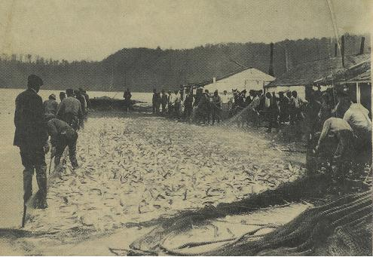
Procedure:

Part I

1. Using the data sheet labeled “A”, graph the millions of pounds of shad caught for both the Chesapeake and the Susquehanna River.

2. Use colored pencils to color code the Chesapeake and the Susquehanna River on the graph.

Part II

1. Use data sheet “B” and a new graph paper to plot the number of Shad caught at the Conowingo Dam.

Evaluation:

1. When were the most Shad caught in the Chesapeake?

2. Compared to 1900, what percentage of Shad were caught in 1905 (in the Chesapeake)?

3. Look at the “historical information.” Why do you think the number of Shad caught in the Chesapeake in 1905 dropped so much?

4. What might explain a drop in Shad population after a major event, for example
construction of a dam?

5. What can be done to further restore Shad populations in the Susquehanna River? (List as many ideas as you can)

Data Sheet

A
COMMERCIAL SHAD LANDINGS
(Millions of Pounds of Shad Caught)

Year Chesapeake Bay Susquehanna River
1880 6.8 None
1885 7.0 2.5
1890 8.0 2.2
1895 14.0 2.0
1900 17.0 1.4
1905 9.5 1.2
1910 8.0 0.9
1915 6.0 0.5
1920 8.0 None
1925 7.0 None
1930 8.0 None
1935 4.0 None
1940 3.0 None
1945 4.0 None
1950 4.8 None
1955 5.2 None
1960 3.0 None
1965 4.0 None
1970 5.0 None
1975 1.0 None
1980 1.0 None

HISTORICAL INFORMATION
(Important Dates in American Shad History in the Susquehanna River Basin)

Year Event
1820 Mill Dams eliminated runs to Binghamton, New York
1835 Canal feeder dam at Columbia, Pennsylvania
1866 Pennsylvania regulations requiring fish passage facilities on all dams
1866-86 Five fishways constructed at Columbia with minimal success
1873 First Shad Hatcheries established at Newport, Havre DeGrace and Marietta
1896 Columbia Dam breached
1904 York Haven hydroelectric dam built
1910 Holtwood dam built - East shore fishways included in plans but proved
unsuccessful
1913 West shore passage built at Holtwood, also unsuccessful
1926 Conowingo dam construction began (fishways no longer required due to lack of
success)
1928 Conowingo dam completed
1932 Safe Harbor dam built
1947-63 Restoration studies initiated followed by feasibility and spawning habitat studies
1962 Fish Commission attempts to get fishways at Conowingo dam
1970 Utilities, Fish Commission and federal government agree on restoration plan
1971 First egg transplant
1972 Conowingo Fish lift completed (West side)
1972 Tropical storm Agnes (June) effecting shad population in upper Chesapeake Bay
1975-74 124 million eggs transplanted
1976 Susquehanna River Anadromous Fish Restoration Committee (SRAFRC) formed
1972-80 Seven million shad fry and fingerlings stocked in Juniata River
1972-80 Only 945 shad collected at Conowingo fish lift for entire time period

EXTENSION: CAPTURE OF RETURNING ADULT SHAD
(Number of Shad Caught)
Data Sheet

B
Year Conowingo Dam Fish Lifts
1981 750
1982 1,500
1983 500
1984 None
1985 1,250
1986 4,750
1987 6,500
1988 4,700
1989 6,250
1990 15,000
1991 26,000
1992 24,500
1993 16,000
1994 31,000
1995 61,000
1996 38,000
1997 90,971
1998 39,904
1999 69,712
2000 153,546
2001 193,574 (record)
2002 108,001
2003 125,135
2004 109,360
2005 68,853
2006 56,830
2007 25,464
2008 19,914
2009 29,272

EXTENSION: HISTORICAL INFORMATION
(Important Dates in Recent American Shad History in the Susquehanna River Basin)

Year Event
1972 Conowingo fish lift completed on West side
1980 Shad fishing closed on all Maryland waters of the Chesapeake Bay
1984 Three utilities above Conowingo dam agree to provide $3.7 million to fund restoration efforts
1985-94 150,000 adult shad released to spawn above dams and 100 million shad fry released
1991 Conowingo fish lift completed on East side, but doesn’t pass fish
1993 Three utilities above Conowingo agree to construct permanent fish passage facilities
1995 Holtwood fish lift completed
1997 Safe Harbor fish lift comes online, Conowingo passes fish
2000 Completion of York Haven fish passage structure
2001 DCNR agrees to provides fish passage past inflatable dam at Shikellamy State Park, Sunbury
2002 Lifts were temporarily shutdown on May 13-14 thru May 23-27 due to high water
2003 Shad lift operations ceased after June 3 due to high waters

